1.Create a new process by invoking the appropriate system call. Get the process identifier of the

currently running process and its respective parent using system calls and display the same

using a C program.

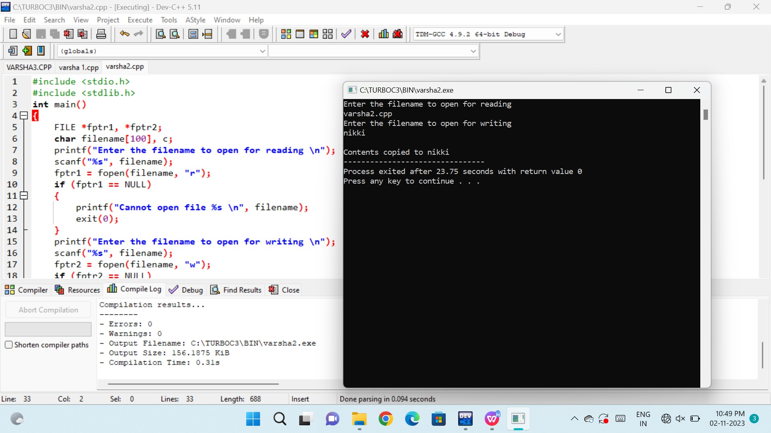

2.Identify the system calls to copy the content of one file to another and illustrate the same using

a C program.

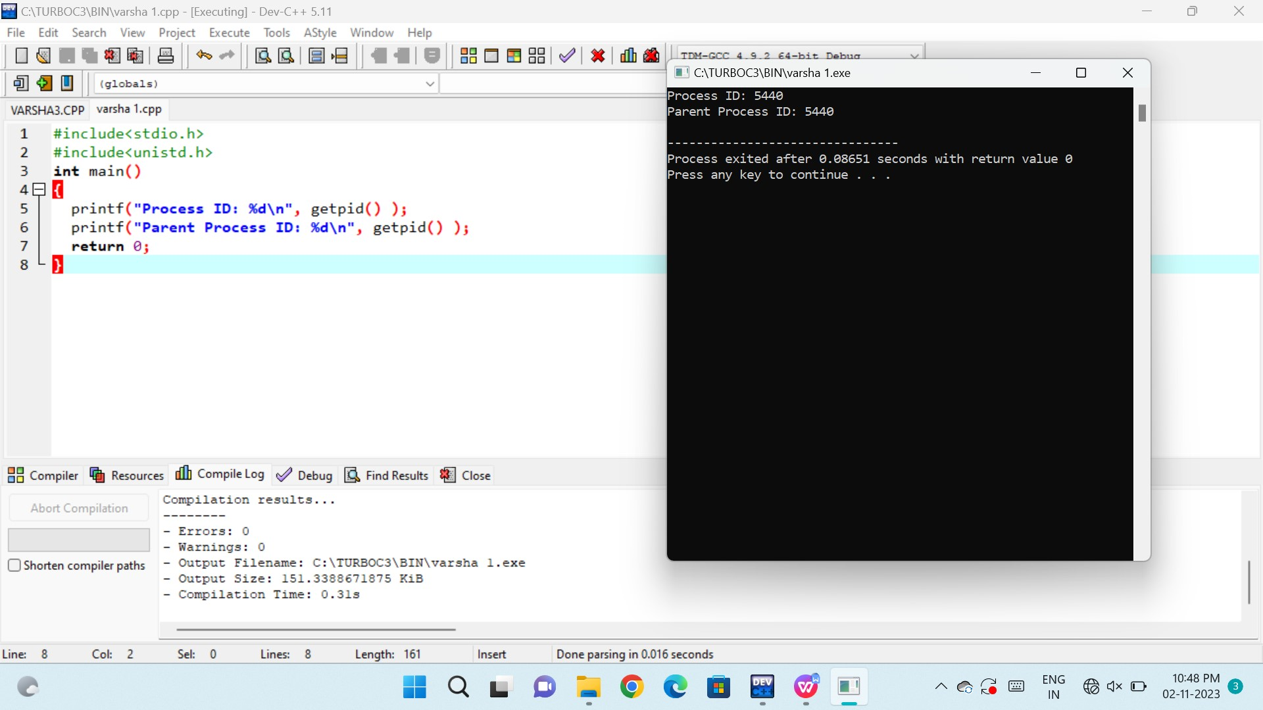

3. Design a CPU scheduling program with C using First Come First Served technique with the

following considerations.

a. All processes are activated at time 0.

b. Assume that no process waits on I/O devices

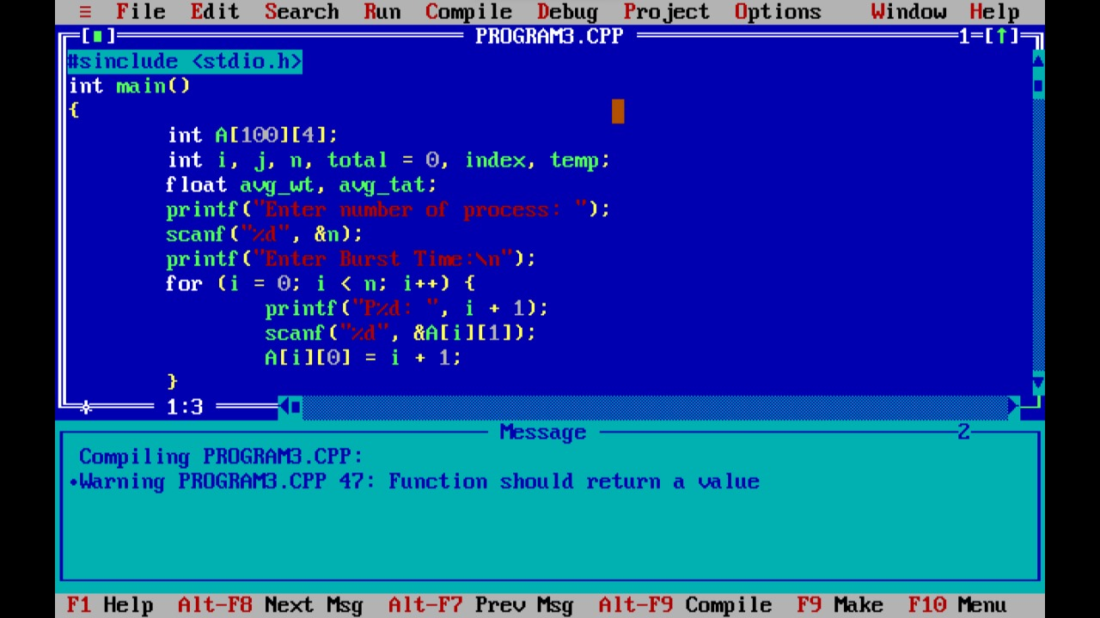



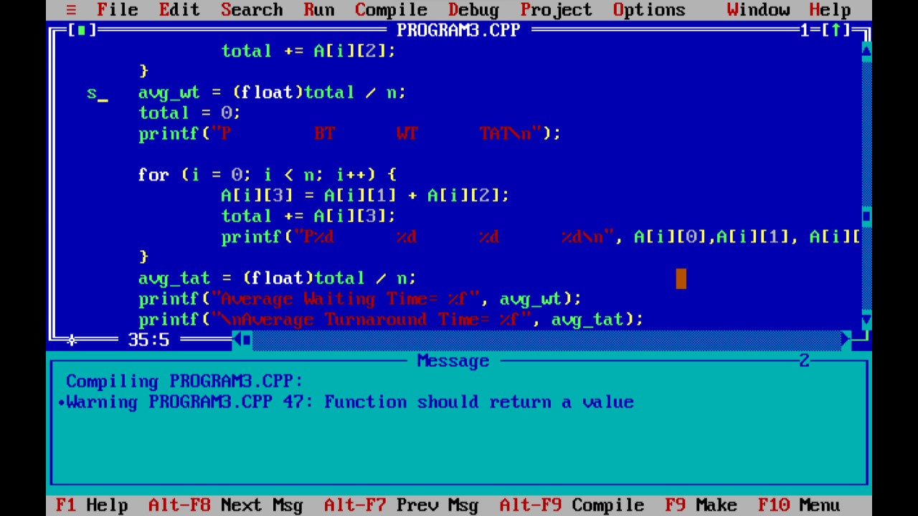

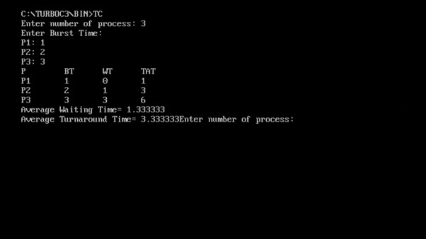

4. Design a CPU scheduling program with C using First Come First Served technique with the

following considerations.

a. All processes are activated at time 0.

b. Assume that no process waits on I/O devices

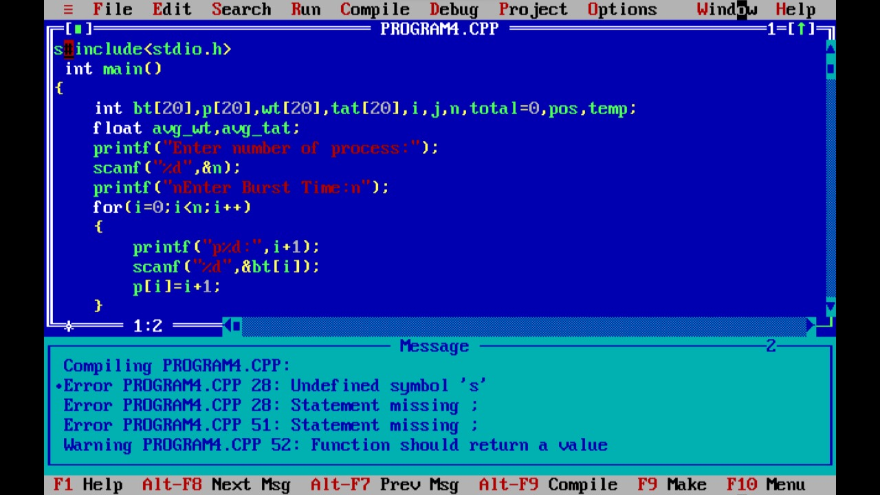

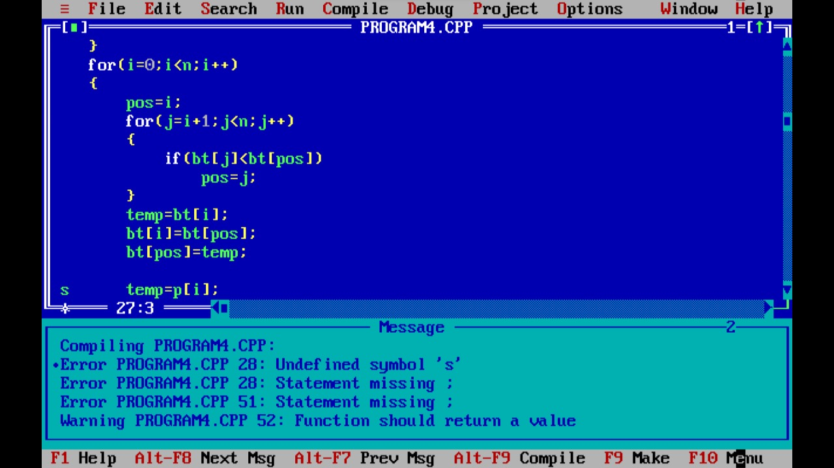

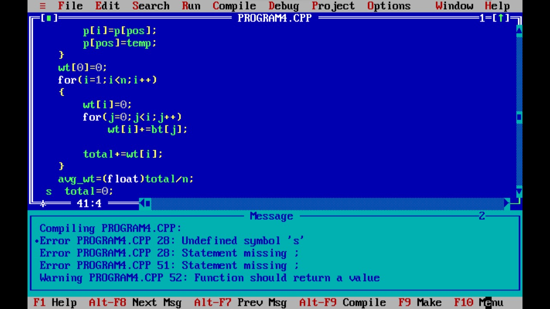

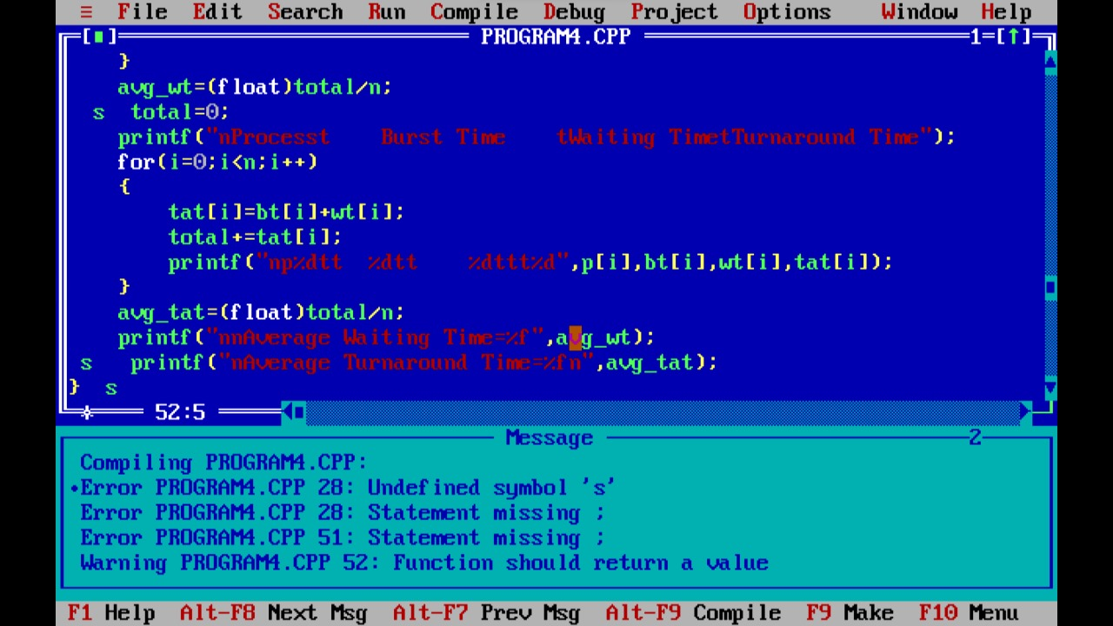

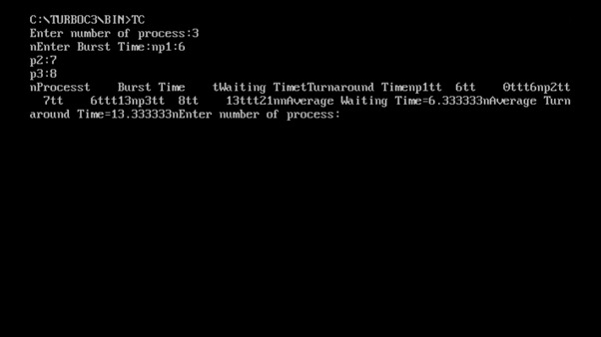

5. Construct a scheduling program with C that selects the waiting process with the highest

priority to execute next.

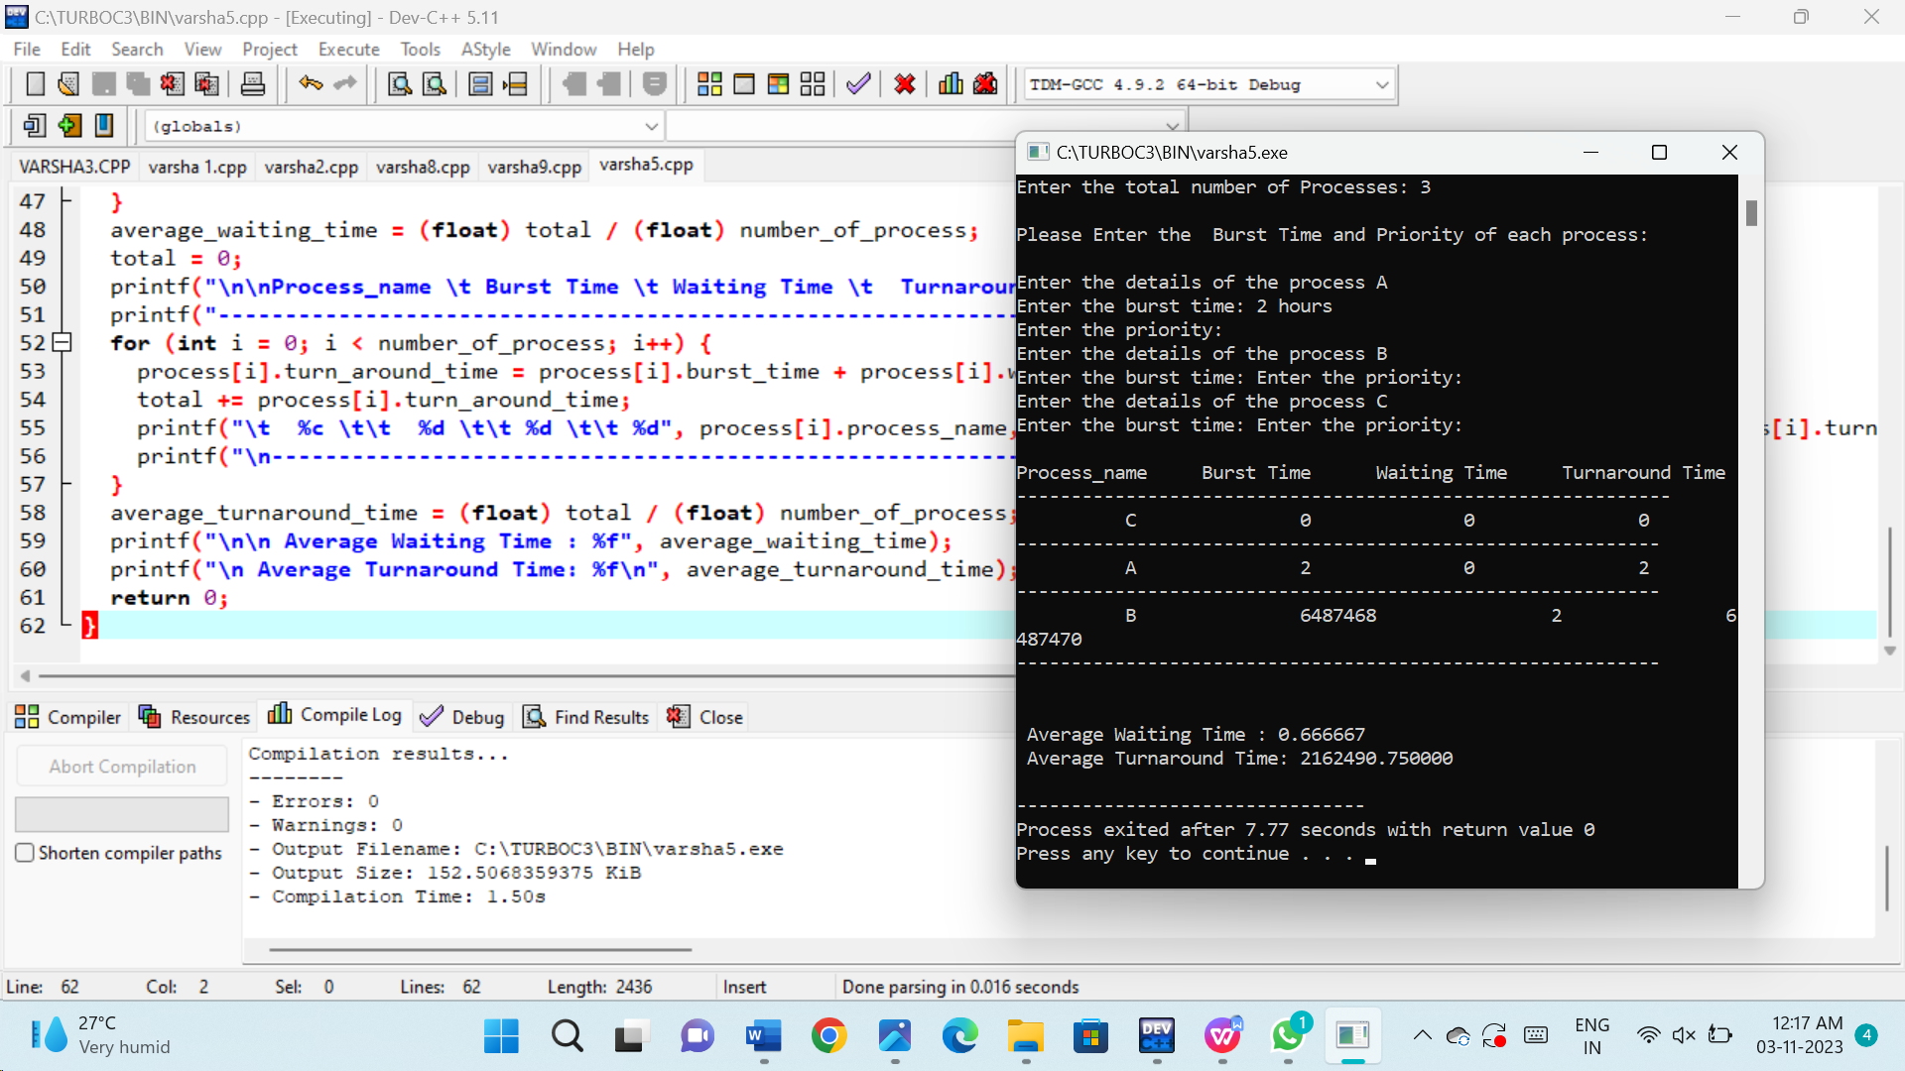

6.Construct a C program to implement pre-emptive priority scheduling algorithm.

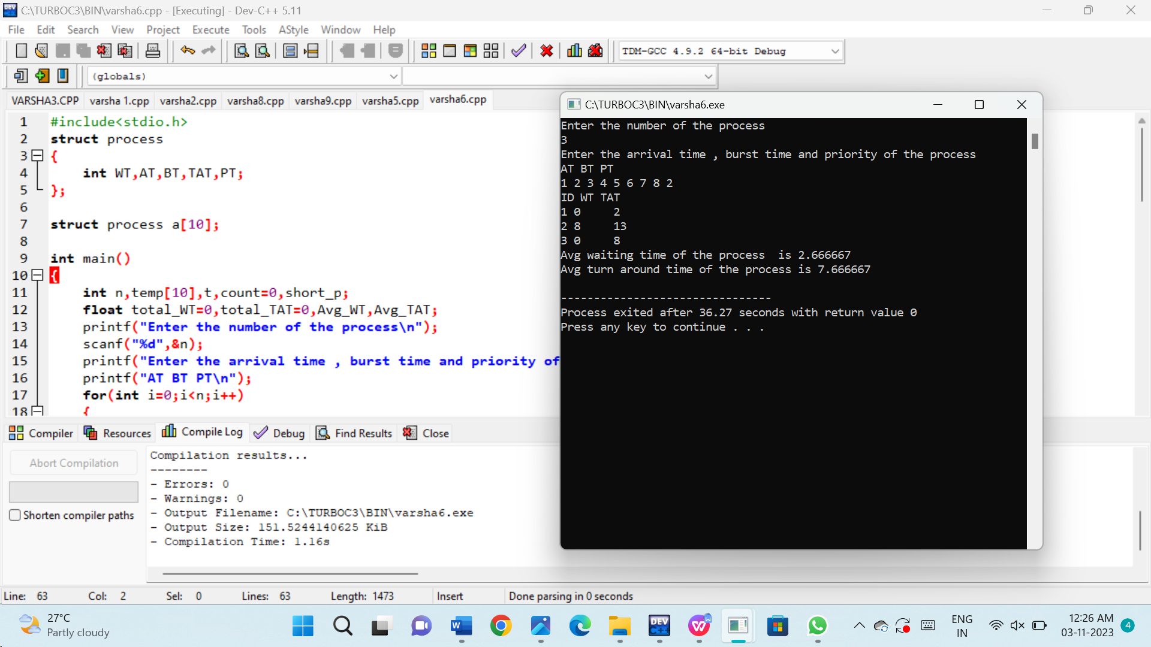

7. Construct a C program to implement non-preemptive SJF algorithm.

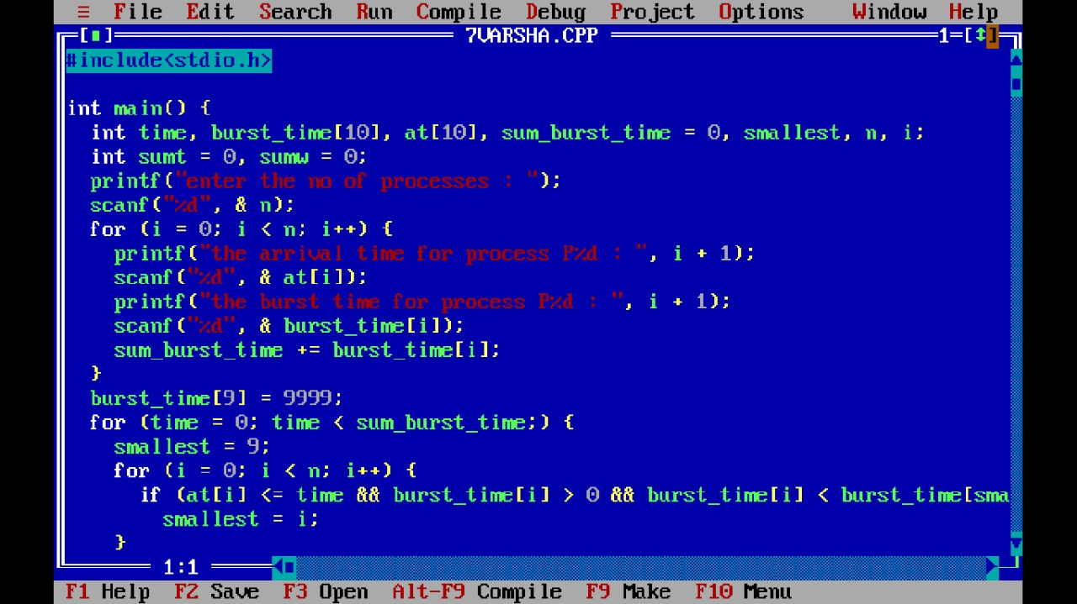

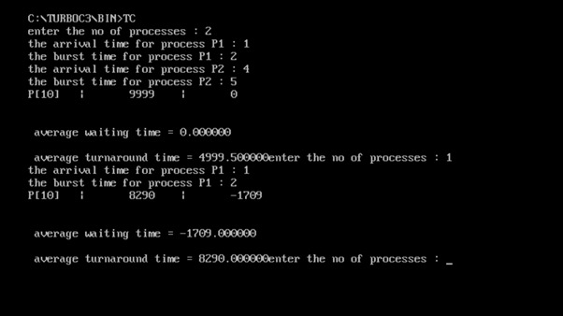

8. Construct a C program to simulate Round Robin scheduling algorithm with C.

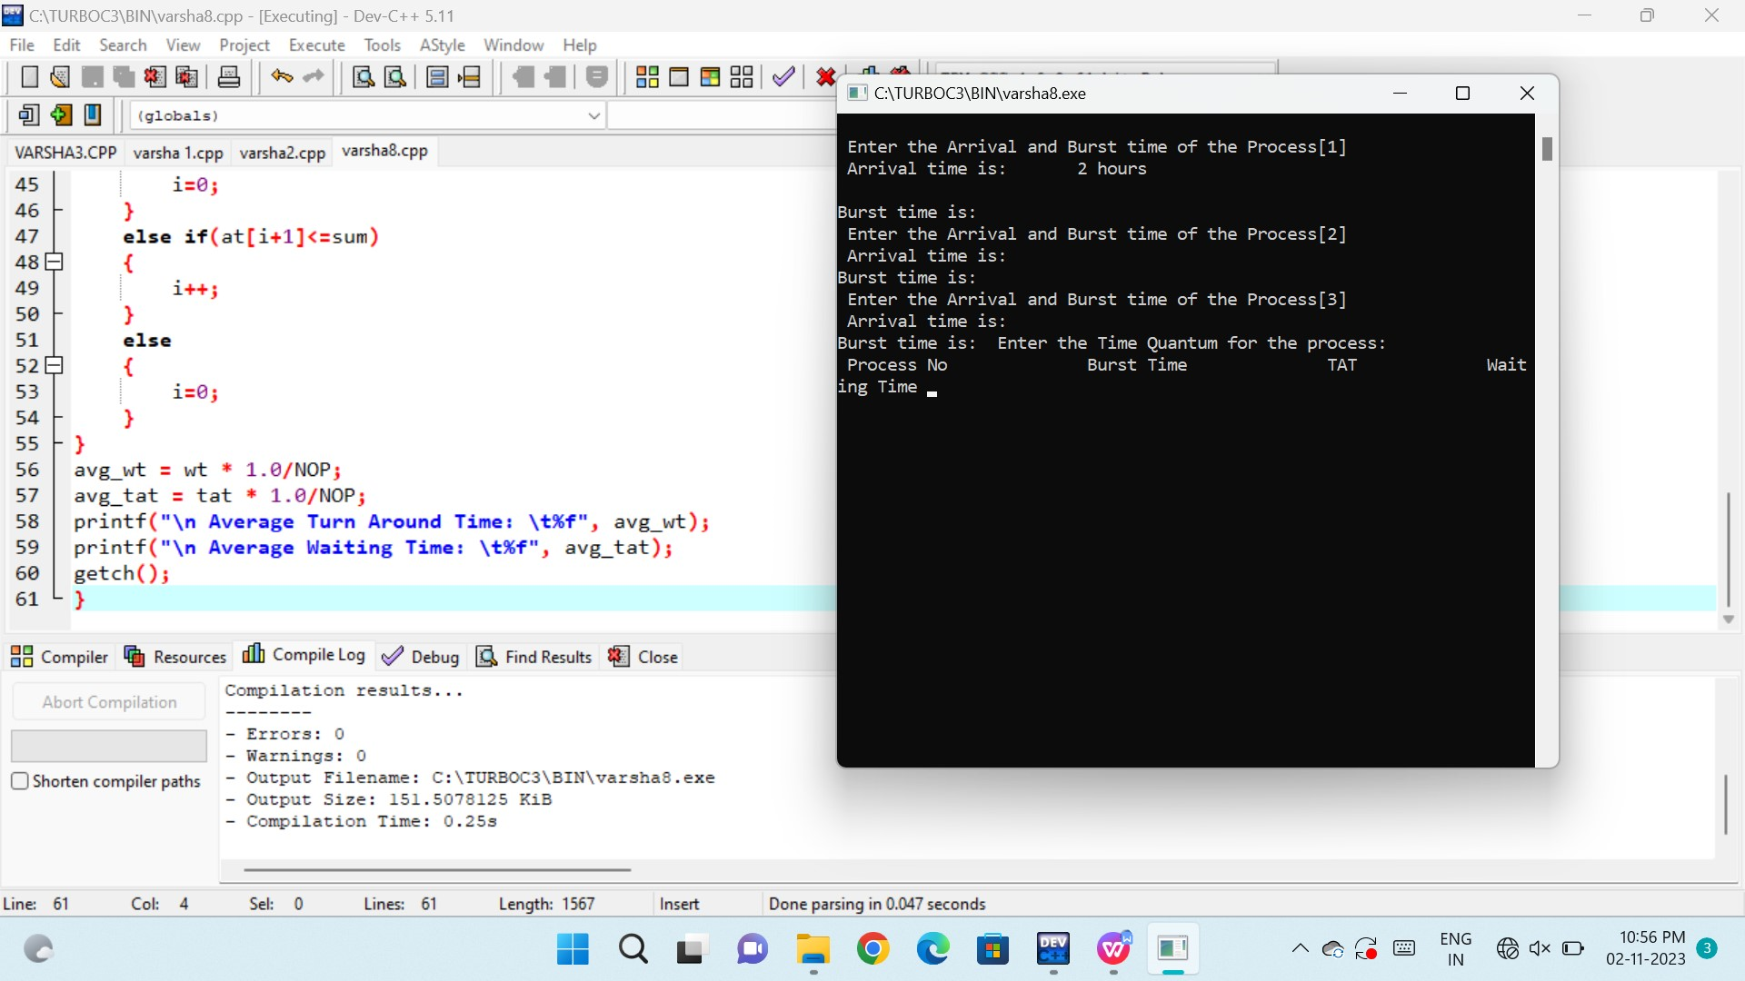

9.Illustrate the concept of inter-process communication using shared memory with a C program.

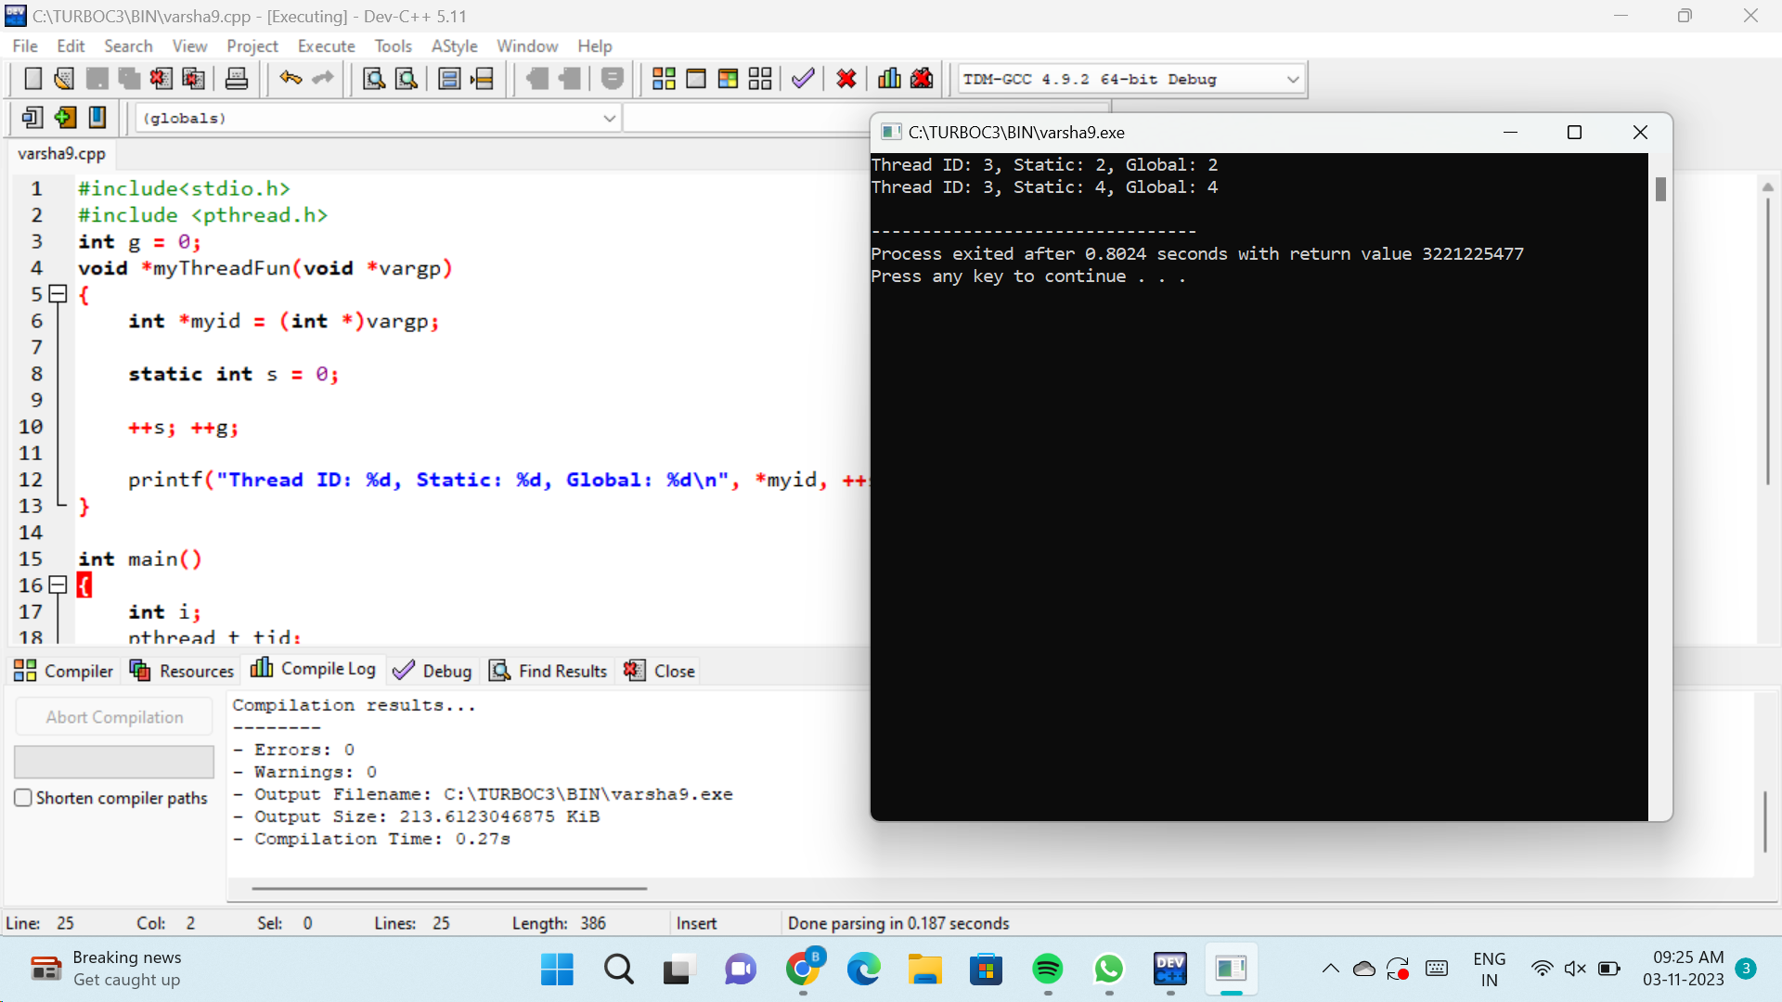

10. Illustrate the concept of inter-process communication using message queue with a C

Program

